PhD FELLOWSHIP  Application form  Call deadline: 1 March 2019  Duration of research project:  September 2019 – August 2023 |  |  |  | 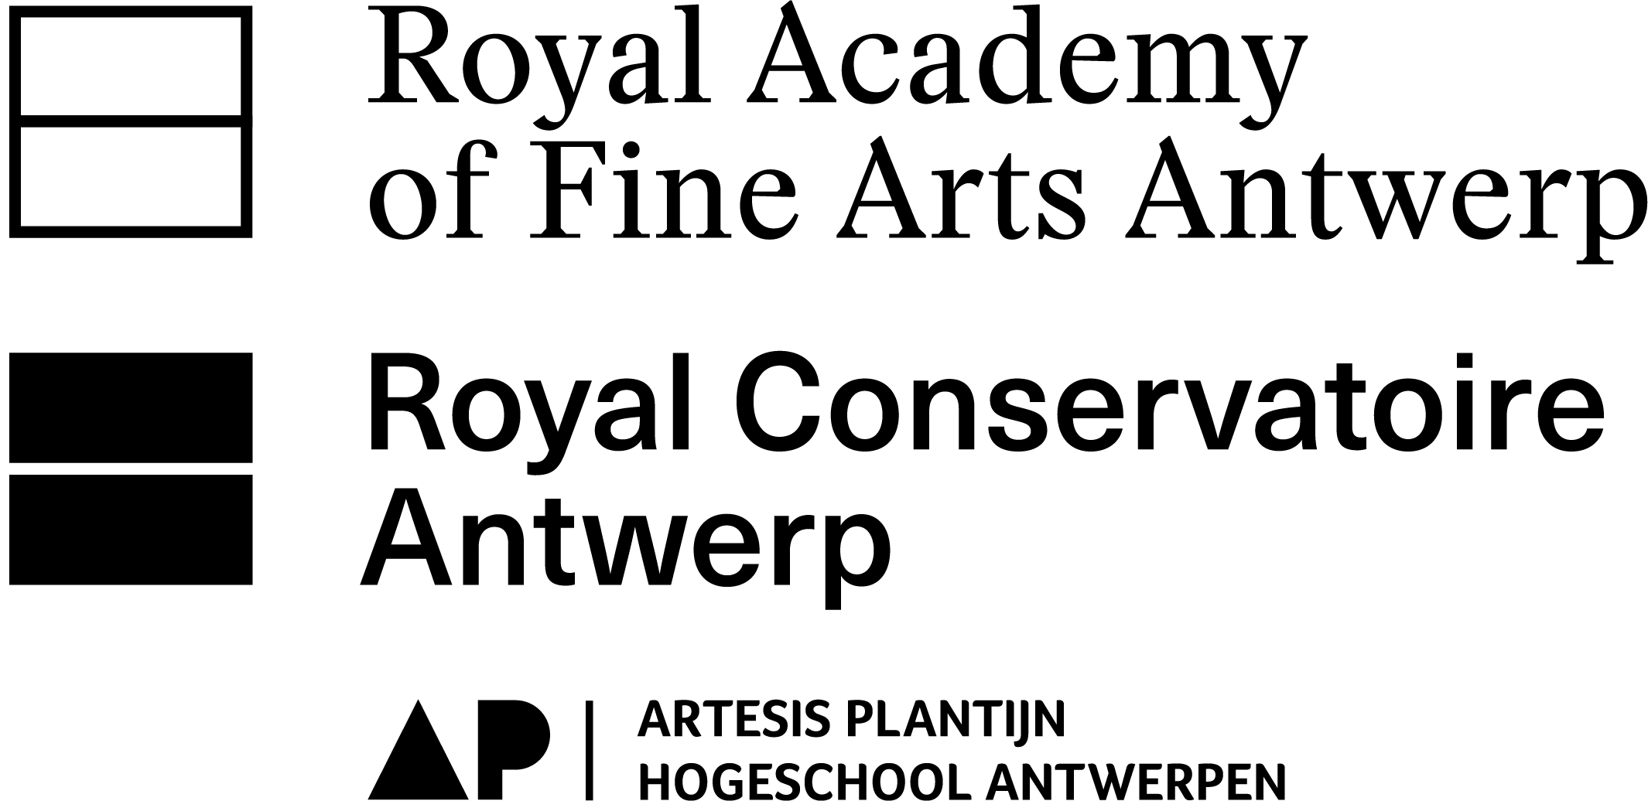
Final date of submission: 1 March 2019 - 12:00 noon
Means of submission: 2 digital versions (Word + PDF) via WeTransfer

Submit to:
Royal Academy Antwerp: Els DE BRUYN - 03 213 71 20 - els.debruyn@ap.be Royal Conservatoire Antwerp: Kevin VOETS - 03 244 18 27 - kevin.voets@ap.be

Do you have any questions, or would you like a research coordinator or research group to give feedback on your proposal? Please inform them in time. Please ensure that you meet with the research coordinator before 15 January and send him/her the documents at least three weeks before the deadline of 1 March so that there is enough time to consider your proposal.

The selection procedure involves an interview. An artistic entrance exam may also be required.

This fellowship funds a PhD student in the arts for a four-year period by means of a part-time appointment as a researcher. The PhD project must tie in with the current research and/or activities of the existing research groups at the Schools of Arts or ARIA.

Identification of the project
Project title
Start date
End date
PhD student
E-mail addresss PhD student
School of Arts supervisor
University supervisor
3 key words
Flemish research discipline list
Select a maximum of three relevant codes from the FLEMISH RESEARCH DISCIPLINE LIST, (see appendix). The list is very extensive, but you will find most relevant codes under ARTS (that category starts on line 2.768).
Summary in lay terms
Maximum 1500 characters (spaces included).
Must include: subject; research question(s); goal of the research project; theoretical and artistic context and methodology
Detailed description of the project
Description of the project
Maximum 7500 characters (spaces included; source references not included).
Must include: subject; research questions; theoretical and artistic context; methodology; reporting and output, relevant sources and / or literature
Planning of the project
At least 1000 characters per year (spaces included).
Indicate briefly the plan for the research activities per year. Take into account that you will be required to report on the progress of your research on an annual basis (interim report: every year in the spring).
2019 (from Sep)
2020
2021
2022
2023 (till Sep)
Explain how and why this research project ties in with the activities of the Schools of Arts research groups; collaboration with other research groups and institutions; link to international forums or institutions.
Maximum 2500 characters (spaces included). Be as specific as possible.
Research group supporting your research:
Remove the research groups that do not apply.
It is not mandatory, but strongly recommended that a research group supports your research project.
Please contact the chair or coordinator of the research group so that he/she is aware of your research project and whether or not can support it. The chair’s signature is also required to formalise this application (see last page).
Royal Conservatoire
Labo XIX-XX - Chair: Jan Dewilde
Uitvoeringspraktijk in perspectief - Chair: Eugeen Schreurs (Music) – Clara van den Broek (Drama)
CORPoREAL - Chair: Annouk Van Moorsel
CREATIE - Chair: Ine Vanoeveren
Royal Academy
ArchiVolt - Chair: Thomas Crombez
Thinking Tools - Chair: Inge Henneman / Steven Humblet
Body and Material Reinvented - Chair: Ria De Boodt
MAXLab - Chairs: Janna Beck / Kristof Timmerman
Other
☐ Other (e.g. Visual Poetics,…): …
☐ Is not connected to or supported by an existing research group
Relevance of the project
Intended outcomes and relevance for:
- the research group supporting the project
- the higher education in the arts
- society (societal and artistic relevance)
Maximum 5000 characters (spaces included).
Composition of the project team
School of Arts supervisor
Name
School of Arts and main subject
E-mail address
University supervisor
Name
University and main subject
E-mail address
School of Arts and university researchers (who actively perform research activities)
Name and School of Arts |  |  |  | Role/assignment |  | Workload in FTE |  | Period
Cooperation with other university colleges or universities
University college/University |  |  |  | Name |  |  |  | Role/assignment
Cooperation with organisations from the field of action (arts)
Organisation |  |  |  | Name |  |  |  | Role/assignment
Relevant expertise of researchers involved
Give an overview of the research experience that is relevant to this particular project (e.g. completed and/or current research projects) of the project coordinator, researchers and external partners. If the researchers or partners have not yet been determined, indicate the types of profile you would like to recruit to fill the vacant position(s).
Maximum 7500 characters (spaces included).
Budget for the project
The PhD student will receive a remunerated 50% appointment as a research staff member for a period of four academic years. The annual extension of the contract is subject to the positive evaluation of the progress report.
Also, the PhD student may receive operational budget and educational credit:
- an annual operational budget of 1000 euros from the School of Arts;
- 1000 euros from UAntwerp for the organisation of a research seminar;
- a lump sum of 3000 euros from UAntwerp for operational expenses throughout the entire duration of the PhD programme for PhD students whitout additional funding (like FWO). Please fill out the appendix ‘Application form Academicisation BOF 2019 – Arts‘;
- 1500 euros in educational credit from UAntwerp, for PhD students who are taking the full PhD programme.
Comments or clarification (optional):
Maximum 1000 characters (spaces included).
External funding
If you have obtained or applied for funding elsewhere, indicate these additional sources of funding in the table below:.
Source of funding |  | Amount applied for | Amount obtained |  | Credit year |  | Debit item*
* Debit item: staff costs, operational costs or investment costs
If additional/alternative funding (e.g. a grant) is also being applied for this research project, please indicate the source:
☐ FWO
☐ BOF
☐ Other: …
Appendices
Please include the following appendices with further information on the PhD candidate (maximum 4 pages as one PDF document):
- Artistic CV (detailed CV relevant to the project)
- Overview of completed research projects
- Link to a personal website or a digital portfolio – we recommend that you first contact your research coordinator (see p.1) to discuss the format of your portfolio.
Signatures
The research coordination also accepts a statement by e-mail from the supervisor and the chairman of a research group, to replace the signatures.

Chair of research group: School of Arts supervisor:

University supervisor:

