MANUAL  Application form  Call: 1 December 2020 | 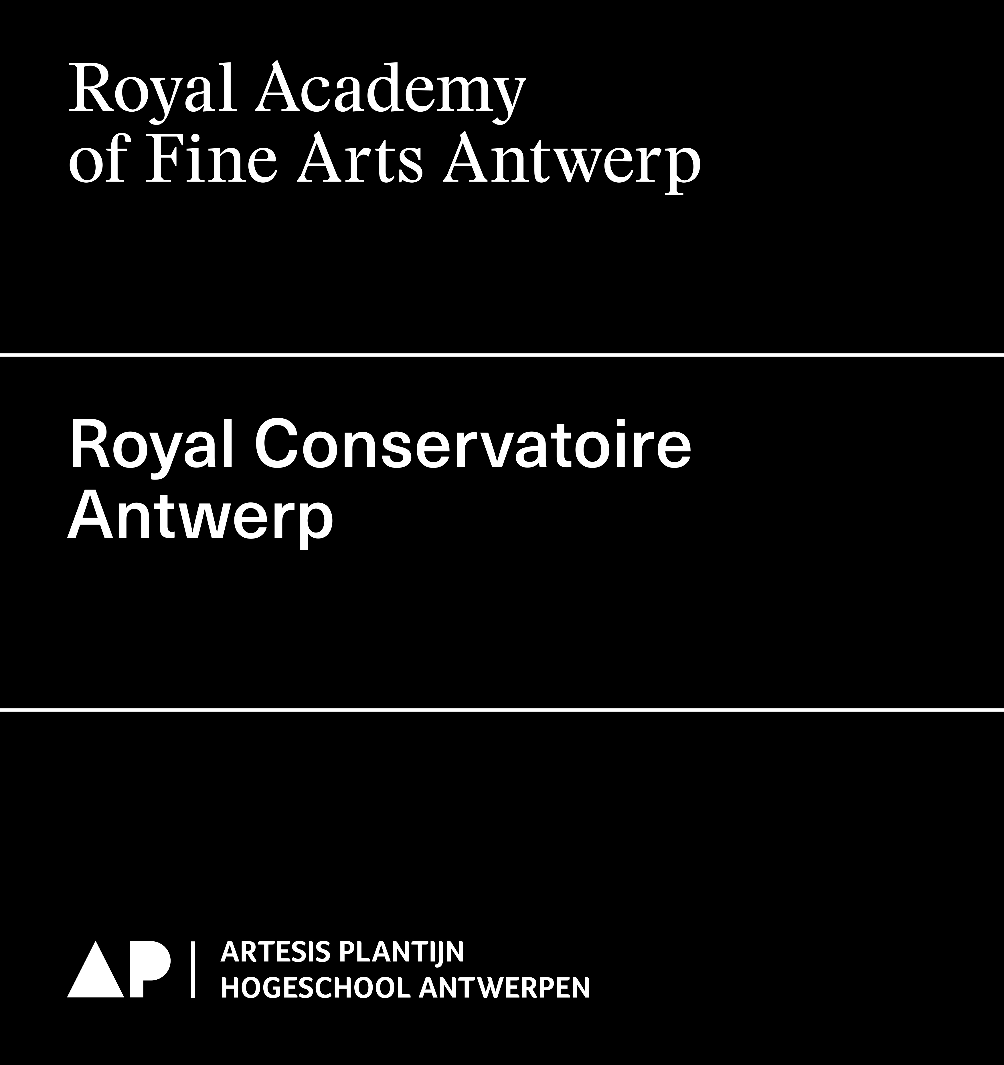
Final date of submission 1 December 2020 at 12.00 p.m. (noon)
Way of submission This application form in word + PDF
Submit to RAFA: Els DE BRUYN - 03 213 71 20 - els.debruyn@ap.be
RCA: Kevin VOETS - 03 244 18 27 - kevin.voets@ap.be

Applications are required to be embedded in one (or more) research group(s), to be supervised by a promotor and to formally meet all requirements.

The steps to be taken to this end are:
1. Contact the chair(s) of the research group(s) you wish to join so that he/she is aware of your application and can inform you whether or not your application will get the research group’s support. It is advisable to do this well enough in advance, preferably before September.
2. As soon as your application receives the research group’s support, make sure that you have a meeting with the chair(s) of the research group(s) before October for feedback on your proposal. The chair(s) can also advise you on finding a promotor(s) and guide you through your application.
3. Send the research coordinator (Els De bruyn for RAFA - Kevin Voets for RCA) your detailed and supported research proposal no later than 10 November 2020 so that he/she has time to give feedback on your proposal.
4. Upon submission, a signature of the promotor is required for your application to be formally in order. It is also recommended that the chair(s) of the (primary and secondary) research groups that support your proposal sign the application (see last page).

If you have any questions about this form or the procedure, please contact the research coordinator (Els De bruyn for RAFA - Kevin Voets for RCA).

This manual is intended to help you in completing the application forms for research projects. Some general tips and important terms are clarified. Take into account the requested information in your application form only, since the list of terms in this manual may be more elaborate than requested in your application form.

General advice for the application of research proposals
- A research proposal gives an idea of the subject or the problem you want to study, and how you will carry out your research.
- Your research questions are the basis of your project: what do you want to research? The methodology describes in a clear way how you will answer the research questions. Make sure that the methodology you choose is tailored to the research questions you propose and that the chosen methods indeed allow you to reach the insights you aim to develop in your research.
- Make sure that your proposal is specific and clear. What exactly do you want to investigate? Do not skip steps of the thinking process. Define the important concepts of your research in an accurate and complete way.
- Make sure that your proposal is feasable within the given research duration. Are there no unrealistic promises made?
- Is your research challenging and innovative? Has your research been performed elsewhere? Does it increase our (general or specific) knowledge?
- To what extent is your research relevant for the Higher Arts Education in general, and for RCA or RAFA in particular? To what extent does it contribute to the enrichment of existing research and/or research groups?
- To what extent is your research relevant for artistic and societal purposes?
- Is the intended output (specific realisations) formulated in a detailed way?
- A good research proposal tells a coherent story. Is your research well defined? What will you investigate, and what not? Check for unnecessary diversions in your proposal.

Specification of terms and concepts
Research project title
Formulate the title clearly and condensed.
Requested budget
Indicate the total requested budget (one amount). The total of staff, operational and investments. If the project is accepted, this project budget will be the guideline. In other words: accepted budgets per year can, in principle, no longer be modified or altered after submission of the project proposals.
Start date
Indicate the start date of the project (if accepted). The research project could start at the earliest on 16 September 2021.
End date
Indicate the end date of the research project (if accepted). Take the maximal duration of your research proposal into account: start project = 1 year; one-year research project = 1 year; two-year research project = 2 years.
Promotor
Choose one supervisor for your research project.
(This also goes for collaboration projects involving both Schools of Arts, cf. research groups below)

A researcher operates under the artistic supervision of a promotor of the Schools of Arts (RCA or RAFA). This promotor has, beside his/her statute, expertise in the domain of the proposed research. It is important that the promotor is able to supervise the project in principle during the whole intended period. Only members of the Schools of Arts of AP Hogeschool qualify as a promotor.

A promoter can submit a maximum of four application forms per call over all types of projects (ut infra). If more than four application forms are submitted by the same promoter, the research council decides on which four application forms are accepted as being admissible.
Research group(s)
It is advisable to embed your research in one (or more) research group(s) at KAA or KCA.

Primary research group(s)
If you are affiliated with one research group, you indicate that research group as the primary research group and do not mark a secondary research group.

If you are affiliated with a research group at both Schools of Arts (one at KCA and one at KAA) and both research groups support your proposal in an equivalent way, we consider your research to be a collaboration project of KAA and KCA. In that case, you mark both research groups and your application will be assessed by both the KCA Reading Committee and the KAA Reading Committee.
Also in the case of a collaboration project, you choose just one supervisor for your project. The School of Arts to which your supervisor is connected, determines which School of Arts (KAA or KCA) your research will be formally and administratively embedded in.

Secondary research group(s) (OPTIONAL)
If, in addition to the support of your primary research group, you have also found a connection with another research group that also supports your project, albeit to a secondary degree, then you refer to it as a secondary research group. You can mark a secondary research group from both KCA and KAA. Your research project will then not be considered as a collaborative project and your application will only be assessed by the Reading Committee of the School of Arts of your primary research group. Your research is therefore formally embedded in the School of Arts of your primary research group for funding, administration, production, etc.
Subject
Define briefly which subject(s) you will investigate. What is the angle and/or problem that is related to your subject?
Research question
Propose one or more specific, clear research questions which your research will attempt to answer. These questions ought to be challenging and at the same feasible within the given duration and available resources.
Theoretic and artistic framework
Give an overview of the theoretic and artistic framework with references to relevant sources. This framework describes the context of your research and artistic practice in relation to other practices and related research. To which existent research is your research connected? What is already known about your subject in the literature/theory and/or artistic practices?
Methodology
Clarify which research methods you will use or develop and why. Which data or material will be collected/researched? How will they be collected and analysed?
Key words
Give up three key words or combinations of words that emcompass the focus of the research.
List of Flemish research disciplines
Give at least one and maximum three codes. The codes were created at the Flemish government level as a system to classify research based on disciplines. Reporting to the Flemish government about research projects requires the indication of at least one code. Research projects, especially multidisciplinary research projects, take place within different disciplines, therefore the possibility to give up to 3 codes.
Reporting and ouput
Clarify in which way and via which instruments your research project will be disseminated. Think of both the artistic output (e.g. performance, lecture,…) and other output (e.g. research report, paper, article in magazine, symposium, lecture,…). Be as precise and detailed as possible.

All output of research (both textual and non-textual output) must be registered in the database of the academic bibliography of the AP University College. The researcher takes the initiative to register via this form. Based on the registered output, your research project will be evaluated by the Research Council.
Planning of the project
What steps will you take conducting your research? Think of, for example, the theoretic and artistic framework, methodology, data collection, conducting interviews, structure of composition/performance,…
Bibliography / sources
Supply an overview (through the text or in list form) of the most important sources you will use in your research. Contact the research co-ordinators to receive a manual for a bibliography.
Intended outcomes and relevance
To what extent is your research relevant for the supporting research group, the Higher Art Education and society? Which new insights will your research, ideally, provide?
FTE (full-time equivalent)
FTE stands for full-time equivalent. It is a unit between 0 and 1 that expresses the proportion of the personnel post. A full working week of 38 hours (or 40 hours in some organisations) is 1 FTE. A function of, for example, 0,6 FTE corresponds to 22,8 hours a week (0,6 x 38 hours).
Staff costs
Staff costs are the wage costs applied for staff of a research project (researcher, executor,…). Promotors and other supervisors of research projects are usually not paid for their guidance and therefore those costs should not be budgeted in the research proposal.
Operational costs
Operational costs include those costs necessary to realize the daily operation of a research project. Eg. transport costs, travel expenses, accommodation costs, printing costs, organisation costs, use of halls, logistics, etc. Concerning use of halls and technical assistance in the RCA: see document ‘Informatie begroting & planning PRODUCTIEKOSTEN’.
Investments
Investments are the costs for investments of sustainable goods in order to realize a research project. Eg. costs for a laptop, microphone, hard disk, etc.

